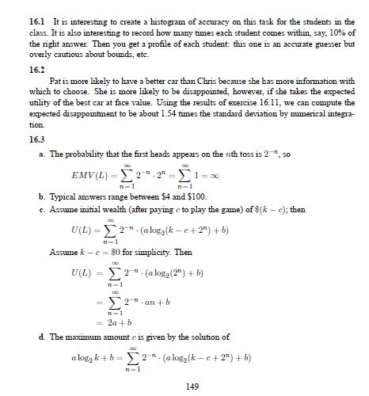 | 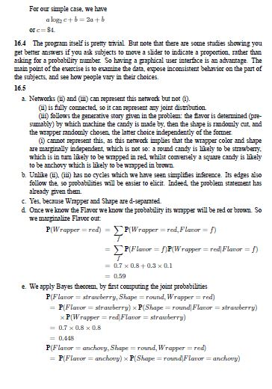 | 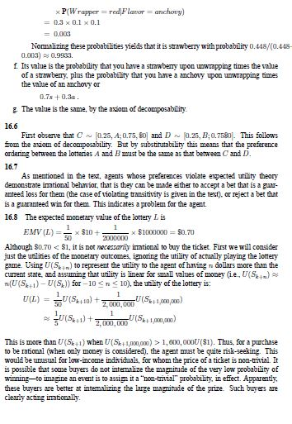
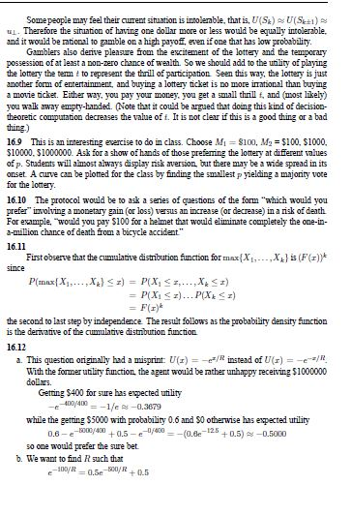 | 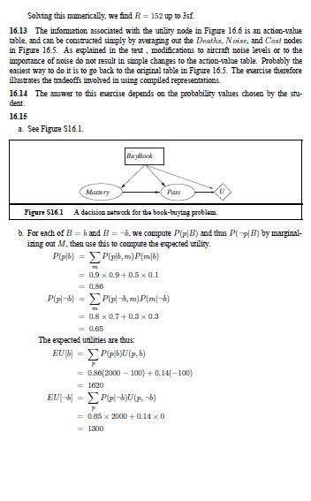 | 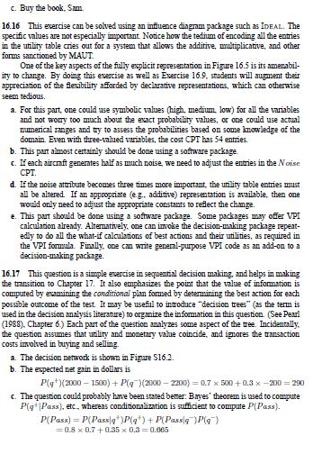
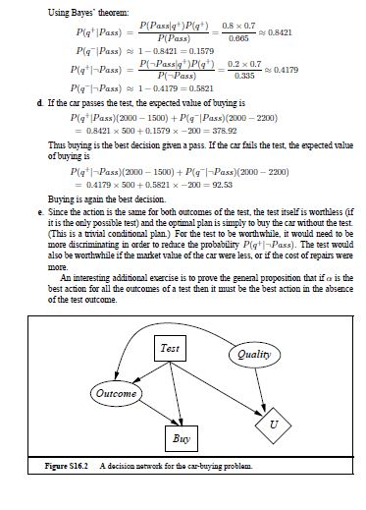 | 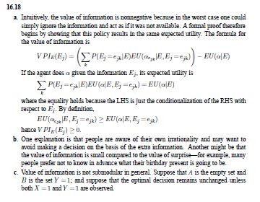 | 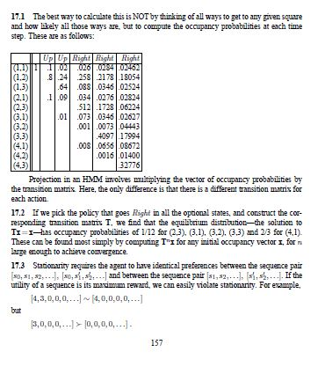

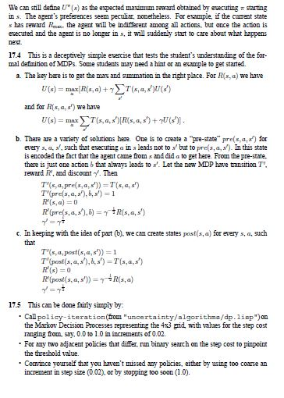 | 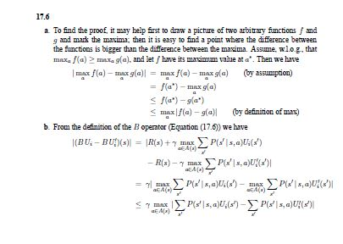 | 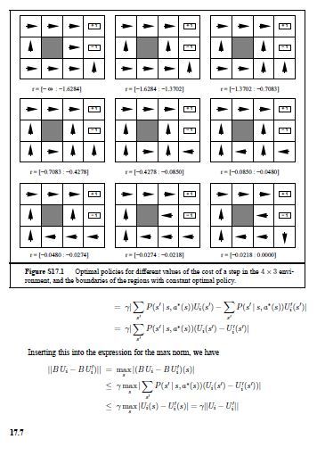

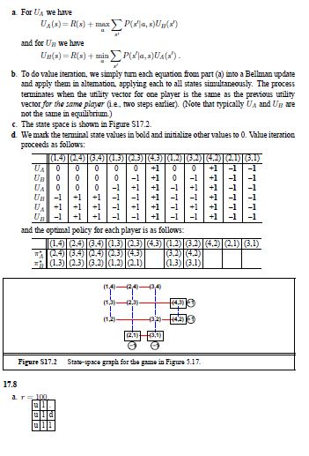 | 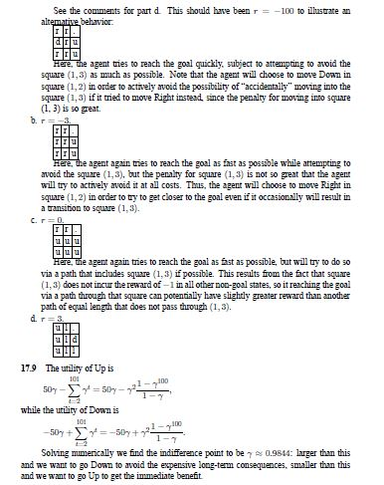 | 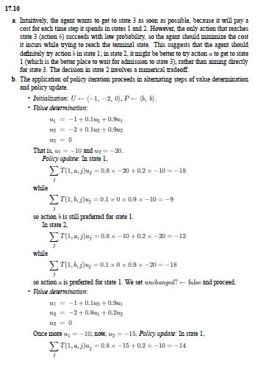
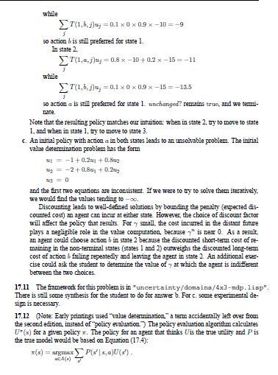 | 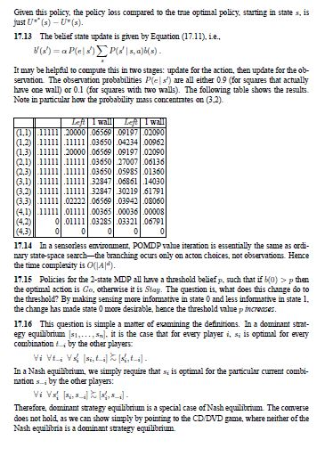 | 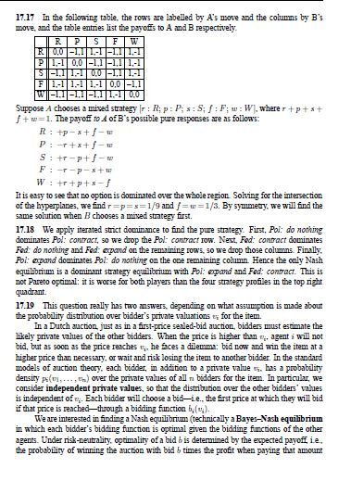

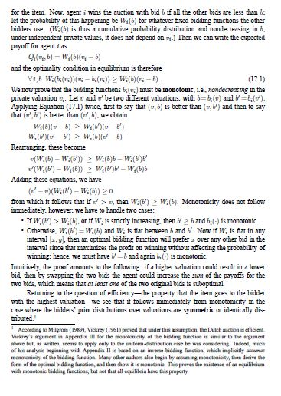 | 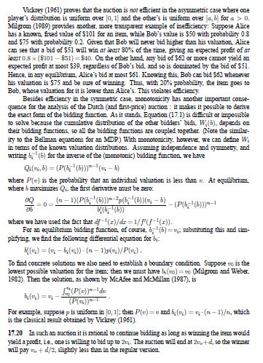 | 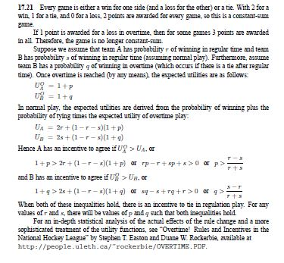
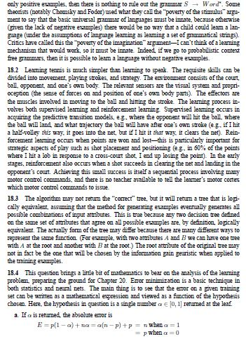 | 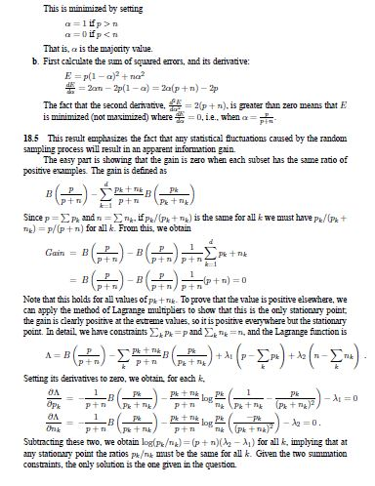 | 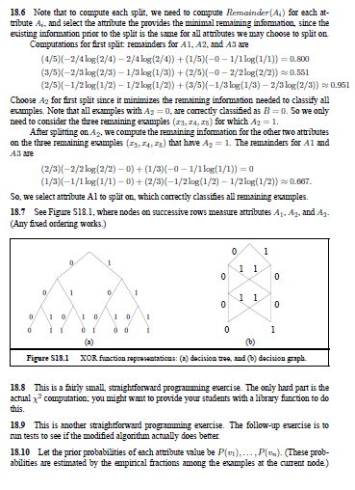

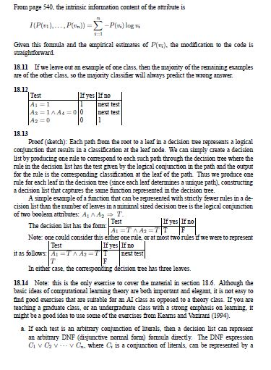 | 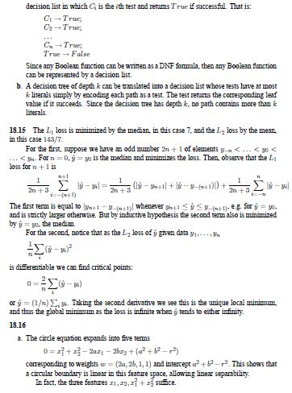 | 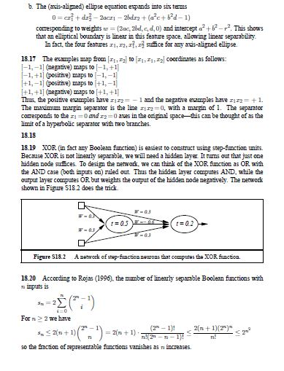
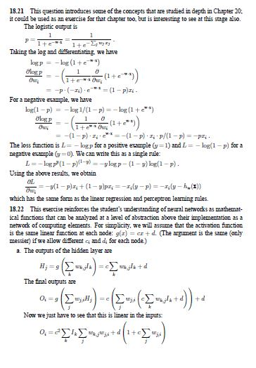 | 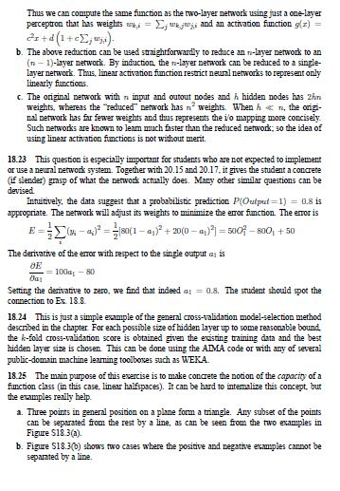 | 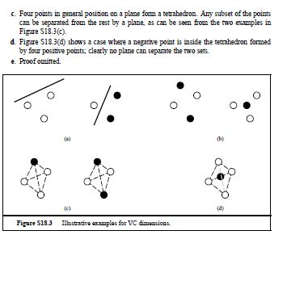

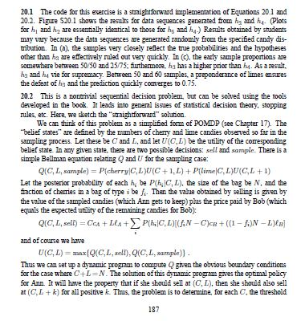 | 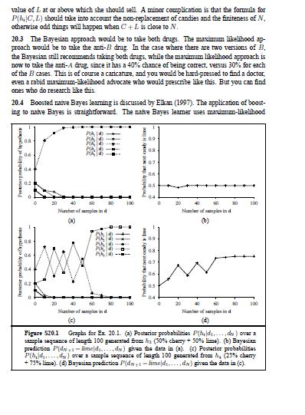 | 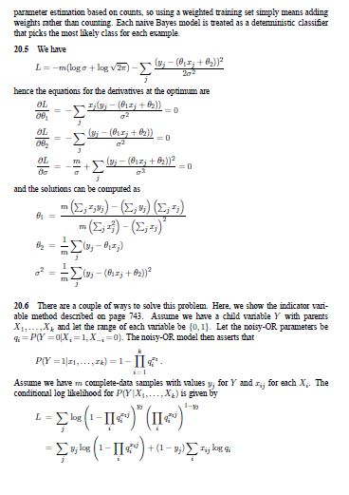
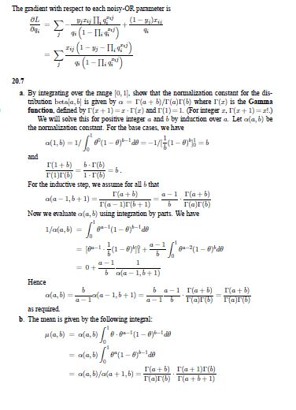 | 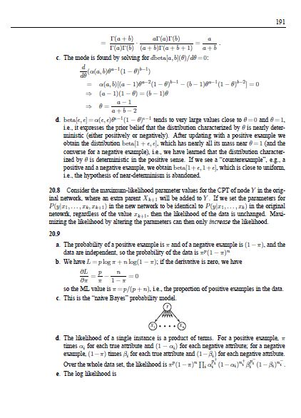 | 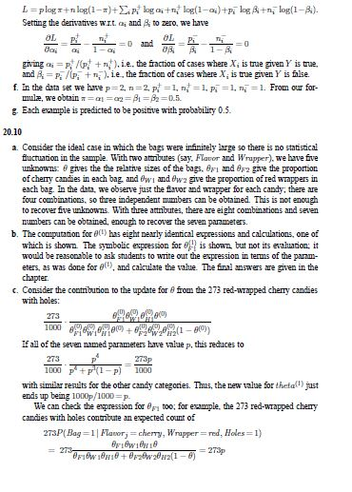

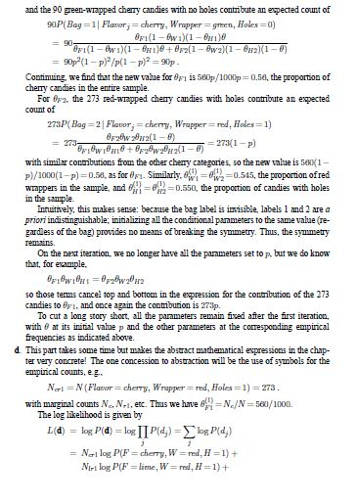 | 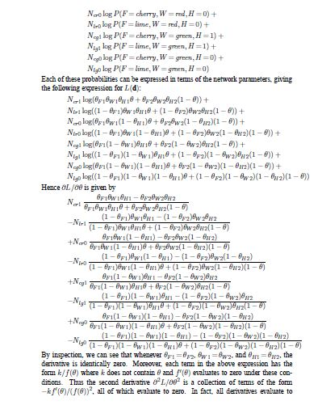 | 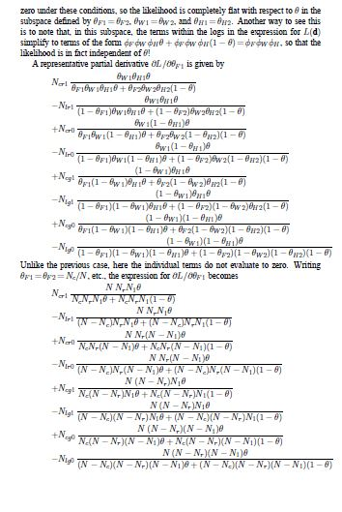
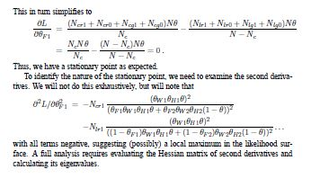 | 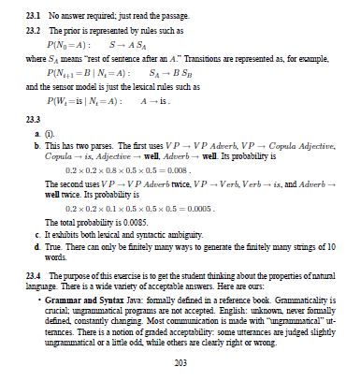 | 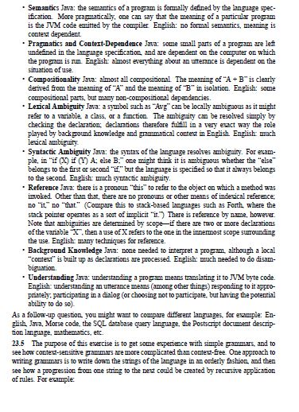

 | 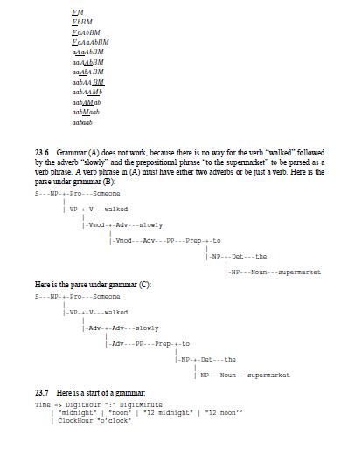 | 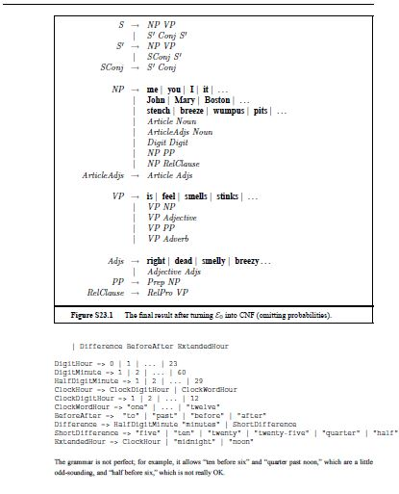
 |  | 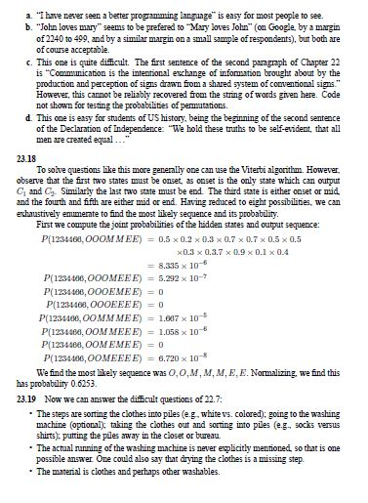

13.3a. True. By the product rule we know P(b, c)P(a|b, c) = P(a, c)P(b|a, c), which by  assumption reduces to P(b, c) = P(a, c). Dividing through by P(c) gives the result.  b. False. The statement P(a|b, c) = P(a) merely states that a is independent of b and c,  it makes no claim regarding the dependence of b and c. A counter-example: a and b  record the results of two independent coin flips, and c = b.  c. False. While the statement P(a|b) = P(a) implies that a is independent of b, it does  not imply that a is conditionally independent of b given c. A counter-example: a and b  record the results of two independent coin flips, and c equals the xor of a and b.  13.4 Probably the easiest way to keep track of what’s going on is to look at the probabilities  of the atomic events. A probability assignment to a set of propositions is consistent  with the axioms of probability if the probabilities are consistent with an assignment to the  atomic events that sums to 1 and has all probabilities between 0 and 1 inclusive. We call the  probabilities of the atomic events a, b, c, and d, as follows:  We then have the following equations:  P(A) = a + b = 0.4  P(B) = a + c = 0.3  P(A ∨ B) = a + b + c = 0.5  P(True) = a + b + c + d = 1  From these, it is straightforward to infer that a = 0.2, b = 0.2, c = 0.1, and d = 0.5.  Therefore, P(A ∧ B) = a = 0.2. Thus the probabilities given are consistent with a rational  assignment, and the probability P(A∧B) is exactly determined. (This latter fact can be seen  also from axiom 3 on page 422.)  If P(A ∨ B) = 0.7, then P(A ∧ B) = a = 0. Thus, even though the bet outlined in  Figure 13.3 loses if A and B are both true, the agent believes this to be impossible so the bet  is still rational.  13.5  a. Each atomic event is a conjunction of n literals, one per variable, with each literal either  positive or negative. For the events to be distinct, at least one pair of corresponding  literals must be nonidentical; hence, the conjunction of the two events contains the  literals Xi and ￢Xi for some i, so the conjunction reduces to False.  b. Proof by induction on n. For n=0, the only event is the empty conjunction True, and  the disjunction containing only this event is also True. Inductive step: assume the claim  holds for n variables. The disjunction for n + 1 variables consists of pairs of disjuncts  of the form (Tn ∧Xn+1)∨(Tn ∧￢Xn+1) for all possible atomic event conjunctions Tn.  Each pair logically reduces to Tn, so the entire disjunction reduces to the disjunction  for n variables, which by hypothesis is equivalent to True.  c. Let α be the sentence in question and μ1, . . . , μk be the atomic event sentences that  entail its truth. Let Mi be the model corresponding to μi (its only model). To prove that  μ1 ∨ . . . ∨ μk ≡ α, simply observe the following:  • Because μi |= α, α is true in all the models of μi, so α is true in Mi.  • The models of μ1∨. . .∨μk are exactlyM1, . . . ,Mk because any two atomic events  are mutually exclusive, so any given model can satisfy at most one disjunct, and  a model that satisfies a disjunct must be the model corresponding to that atomic  event.  • If any modelM satisfies α, then the corresponding atomic-event sentence μ entails  α, so the models of α are exactly M1, . . . ,Mk.  Hence, α and μ1 ∨ . . . ∨ μk have the same models, so are logically equivalent. | 13.6 Equation (13.4) states that P(a ∨ b) = P(a) + P(b) − P(a ∧ b). This can be proved  directly from Equation (13.2), using obvious abbreviations for the possible-world probabiliTIES:  P(a ∨ b) = pa,b + pa,￢b + p￢a,b  P(a) = pa,b + pa,￢b  P(b) = pa,b + p￢a,b  P(a ∧ b) = pa,b .  13.7 This is a classic combinatorics question that could appear in a basic text on discrete  mathematics. The point here is to refer to the relevant axioms of probability: principally,  axiom 3 on page 422. The question also helps students to grasp the concept of the joint  probability distribution as the distribution over all possible states of the world.  a. There are  􀀀(52 5)= (52 × 51 × 50 × 49 × 48)/(1 × 2 × 3 × 4 × 5) = 2,598,960 possible  five-card hands.  b. By the fair-dealing assumption, each of these is equally likely. By axioms 2 and 3, each  hand therefore occurs with probability 1/2,598,960.  c. There are four hands that are royal straight flushes (one in each suit). By axiom 3, since  the events are mutually exclusive, the probability of a royal straight flush is just the sum  of the probabilities of the atomic events, i.e., 4/2,598,960 = 1/649,740. For “four of  a kind” events, There are 13 possible “kinds” and for each, the fifth card can be one  of 48 possible other cards. The total probability is therefore (13 × 48)/2, 598, 960 =  1/4, 165.  These questions can easily be augmented by more complicated ones, e.g., what is the probability  of getting a full house given that you already have two pairs? What is the probability of  getting a flush given that you have three cards of the same suit? Or you could assign a project  of producing a poker-playing agent, and have a tournament among them.  13.8 The main point of this exercise is to understand the various notations of bold versus  non-bold P, and uppercase versus lowercase variable names. The rest is easy, involving a  small matter of addition.  a. This asks for the probability that Toothache is true.  P(toothache) = 0.108 + 0.012 + 0.016 + 0.064 = 0.2  b. This asks for the vector of probability values for the random variable Cavity. It has two  values, which we list in the order htrue, falsei. First add up 0.108 + 0.012 + 0.072 +  0.008 = 0.2. Then we have  P(Cavity) = h0.2, 0.8i .  c. This asks for the vector of probability values for Toothache, given that Cavity is true.  P(Toothache|cavity) = h(.108 + .012)/0.2, (0.072 + 0.008)/0.2i = h0.6, 0.4i  d. This asks for the vector of probability values for Cavity, given that either Toothache or  Catch is true. First compute P(toothache ∨catch) = 0.108+0.012+0.016+0.064+  0.072 + 0.144 = 0.416. Then  P(Cavity|toothache ∨ catch) =  h(0.108 + 0.012 + 0.072)/0.416, (0.016 + 0.064 + 0.144)/0.416i =  h0.4615, 0.5384i | 13.10  a. To compute the expected payback for the machine, we determine the probability for  each winning outcome, multiply it by the amount that would be won in that instance,  and sum all possible winning combinations. Since each symbol is equally likely, the  first four cases have probability (1/4)3 = 1/64.  However, in the case of computing winning probabilities for cherries, we must only  consider the highest paying case, so we must subtract the probability for dominating  winning cases from each subsequent case (e.g., in the case of two cherries, we subtract  off the probability of getting three cherries):  CHERRY/CHERRY/? 3/64 = (1/4)2 − 1/64  CHERRY/?/? 12/64 = (1/4)1 − 3/64 − 1/64  The expectation is therefore  20 · 1/64 + 15 · 1/64 + 5 · 1/64 + 3 · 1/64 + 2 · 3/64 + 1 · 12/64 = 61/64.  Thus, the expected payback percentage is 61/64 (which is less than 1 as we would  expect of a slot machine that was actually generating revenue for its owner).  b. We can tally up the probabilities we computed in the previous section, to get  1/64 + 1/64 + 1/64 + 1/64 + 3/64 + 12/64 = 19/64.  Alternatively, we can observe that we win if either all symbols are the same (denote  this event S), or if the first symbol is cherry (denote this event C). Then applying the  inclusion-exclusion identity for disjunction:  P(S ∨ C) = P(S) + P(C) − P(S ∧ C) = (1/4)2 + 1/4 − 1/64 = 19/64.  13.11 The correct message is received if either zero or one of the n + 1 bits are corrupted.  Since corruption occurs independently with probability ǫ, the probability that zero bits are  corrupted is (1 − ǫ)n+1. There are n + 1 mutually exclusive ways that exactly one bit can  be corrupted, one for each bit in the message. Each has probability ǫ(1 − ǫ)n, so the overall  probability that exactly one bit is corrupted is nǫ(1 − ǫ)n. Thus, the probability that the  correct message is received is (1 − ǫ)n+1 + nǫ(1 − ǫ)n.  The maximum feasible value of n, therefore, is the largest n satisfying the inequality  (1 − ǫ)n+1 + nǫ(1 − ǫ)n ≥ 1 − δ.  Numerically solving this for ǫ = 0.001, δ = 0.01, we find n = 147.  13.12 Independence is symmetric (that is, a and b are independent iff b and a are independent)  so P(a|b) = P(a) is the same as P(b|a) = P(b). So we need only prove that P(a|b) =  P(a) is equivalent to P(a ∧ b) = P(a)P(b). The product rule, P(a ∧ b) = P(a|b)P(b), can  be used to rewrite P(a ∧ b) = P(a)P(b) as P(a|b)P(b) = P(a)P(b), which simplifies to  P(a|b) = P(a).
13.13  Let V be the statement that the patient has the virus, and A and B the statements that  the medical tests A and B returned positive, respectively. The problem statement gives:  P(V ) = 0.01  P(A|V ) = 0.95  P(A|￢V ) = 0.10  P(B|V ) = 0.90  P(B|￢V ) = 0.05  The test whose positive result is more indicative of the virus being present is the one whose  posterior probability, P(V |A) or P(V |B) is largest. One can compute these probabilities  directly from the information given, finding that P(V |A) = 0.0876 and P(V |B) = 0.1538,  so B is more indicative.  Equivalently, the questions is asking which test has the highest posterior odds ratio  P(V |A)/P(￢V |A). From the odd form of Bayes theorem:  P(V |A)  P(￢V |A)  =  P(A|V )  P(A|￢V )  P(V )  P(￢V )  we see that the ordering is independent of the probability of V , and that we just need to  compare the likelihood ratios P(A|V )/P(A|￢V ) = 9.5 and P(B|V )/P(V |￢V ) = 18 to  find the answer.  13.14  If the probability x is known, then successive flips of the coin are independent of each  other, since we know that each flip of the coin will land heads with probability x. Formally,  if F1 and F2 represent the results of two successive flips, we have  P(F1 = heads, F2 = heads|x) = x ∗ x = P(F1 = heads|x)P(F2 = heads|x)  Thus, the events F1 = heads and F2 = heads are independent.  If we do not know the value of x, however, the probability of each successive flip is  dependent on the result of all previous flips. The reason for this is that each successive  flip gives us information to better estimate the probability x (i.e., determining the posterior  estimate for x given our prior probability and the evidence we see in the most recent coin  flip). This new estimate of x would then be used as our “best guess” of the probability of the  coin coming up heads on the next flip. Since this estimate for x is based on all the previous  flips we have seen, the probability of the next flip coming up heads depends on how many  heads we saw in all previous flips, making them dependent.  For example, if we had a uniform prior over the probability x, then one can show that  after n flips ifmof them come up heads then the probability that the next one comes up heads  is (m + 1)/(n + 2), showing dependence on previous flips. | 13.15 We are given the following information:  P(test|disease) = 0.99  P(￢test|￢disease) = 0.99  P(disease) = 0.0001  and the observation test. What the patient is concerned about is P(disease|test). Roughly  speaking, the reason it is a good thing that the disease is rare is that P(disease|test) is proportional  to P(disease), so a lower prior for disease willmean a lower value for P(disease|test).  Roughly speaking, if 10,000 people take the test, we expect 1 to actually have the disease, and  most likely test positive, while the rest do not have the disease, but 1% of them (about 100  people) will test positive anyway, so P(disease|test) will be about 1 in 100. More precisely,  using the normalization equation from page 480:  P(disease|test)  = P(test|disease)P(disease)  P(test|disease)P(disease)+P(test|￢disease)P(￢disease)  = 0.99×0.0001  0.99×0.0001+0.01×0.9999  = .009804  The moral is that when the disease is much rarer than the test accuracy, a positive test result  does not mean the disease is likely. A false positive reading remains much more likely.  Here is an alternative exercise along the same lines: A doctor says that an infant who  predominantly turns the head to the right while lying on the back will be right-handed, and  one who turns to the left will be left-handed. Isabella predominantly turned her head to the  left. Given that 90% of the population is right-handed, what is Isabella’s probability of being  right-handed if the test is 90% accurate? If it is 80% accurate?  The reasoning is the same, and the answer is 50% right-handed if the test is 90% accurate,  69% right-handed if the test is 80% accurate.  13.16 The basic axiom to use here is the definition of conditional probability:  a. We have  P(A,B|E) =P(A,B,E)P(E)  and  P(A|B,E)P(B|E) =P(A,B,E)P(B,E)/P(B,E)/P(E)=P(A,B,E)/P(E)  hence  P(A,B|E) = P(A|B,E)P(B|E)  b. The derivation here is the same as the derivation of the simple version of Bayes’ Rule  on page 426. First we write down the dual form of the conditionalized product rule,  simply by switching A and B in the above derivation:  P(A,B|E) = P(B|A,E)P(A|E)  Therefore the two right-hand sides are equal:  P(B|A,E)P(A|E) = P(A|B,E)P(B|E)  Dividing through by P(B|E) we get  P(A|B,E) =P(B|A,E)P(A|E)/P(B|E) | 13.17 The key to this exercise is rigorous and frequent application of the definition of conditional  probability, P(X|Y ) = P(X, Y )/P(Y ). The original statement that we are given  is:  P(A,B|C) = P(A|C)P(B|C)  We start by applying the definition of conditional probability to two of the terms in this  statement:  P(A,B|C) =  P(A,B,C)  P(C)  and P(B|C) =  P(B,C)  P(C)  Now we substitute the right hand side of these definitions for the left hand sides in the original  statement to get:  P(A,B,C)  P(C)= P(A|C)P(B,C)/P(C)  Now we need the definition once more:  P(A,B,C) = P(A|B,C)P(B,C)  We substitute this right hand side for P(A,B,C) to get:  P(A|B,C)P(B,C)  P(C)  = P(A|C)P(B,C)/P(C)  Finally, we cancel the P(B,C) and P(C)s to get:  P(A|B,C) = P(A|C)  The second part of the exercise follows from by a similar derivation, or by noticing that A  and B are interchangeable in the original statement (because multiplication is commutative  and A,B means the same as B,A).  In Chapter 14, we will see that in terms of Bayesian networks, the original statement  means that C is the lone parent of A and also the lone parent of B. The conclusion is that  knowing the values of B and C is the same as knowing just the value of C in terms of telling  you something about the value of A.

13.18  a. A typical “counting” argument goes like this: There are n ways to pick a coin, and 2  outcomes for each flip (although with the fake coin, the results of the flip are indistinguishable),  so there are 2n total atomic events, each equally likely. Of those, only 2  pick the fake coin, and 2 + (n − 1) result in heads. So the probability of a fake coin  given heads, P(fake|heads ), is 2/(2 + n − 1) = 2/(n + 1).  Often such counting arguments go astray when the situation gets complex. It may  be better to do it more formally:  P(Fake|heads) = αP(heads|Fake)P(Fake)  = αh1.0, 0.5ih1/n, (n − 1)/ni  = αh1/n, (n − 1)/2ni  = h2/(n + 1), (n − 1)/(n + 1)i  b. Now there are 2kn atomic events, of which 2k pick the fake coin, and 2k+(n−1) result  in heads. So the probability of a fake coin given a run of k heads, P(fake|heads k), is  2k/(2k + (n − 1)). Note this approaches 1 as k increases, as expected. If k = n = 12,  for example, than P(fake|heads10) = 0.9973.  Doing it the formal way:  P(Fake|headsk) = αP(headsk|Fake)P(Fake)  = αh1.0, 0.5k ih1/n, (n − 1)/ni  = αh1/n, (n − 1)/2kni  = h2k/(2k + n − 1), (n − 1)/(2k + n − 1)i  c. The procedure makes an error if and only if a fair coin is chosen and turns up heads k  times in a row. The probability of this  P(headsk|￢fake)P(￢fake) = (n − 1)/2kn .  13.19 The important point here is that although there are often many possible routes by  which answers can be calculated in such problems, it is usually better to stick to systematic  “standard” routes such as Bayes’ Rule plus normalization. Chapter 14 describes generalpurpose,  systematic algorithms that make heavy use of normalization. We could guess that  P(S|￢M) ≈ 0.05, or we could calculate it from the information already given (although the  idea here is to assume that P(S) is not known):  P(S|￢M) =P(￢M|S)P(S)/P(￢M)  =(1 − P(M|S))P(S)/1 − P(￢M)  =0.9998 × 0.05/0.99998= 0.049991  Normalization proceeds as follows:  P(M|S) ∝ P(S|M)P(M) = 0.5/50, 000 = 0.00001  P(￢M|S) ∝ P(S|￢M)P(￢M) = 0.049991 × 0.99998 = 0.04999  P(M|S) = 0.00001  0.00001+0.04999 = 0.0002  P(￢M|S) = 0.00001  0.00001+0.04999 = 0.9998 | 13.21 The relevant aspect of the world can be described by two random variables: B means  the taxi was blue, and LB means the taxi looked blue. The information on the reliability of  color identification can be written as  P(LB|B) = 0.75 P(￢LB|￢B) = 0.75  We need to know the probability that the taxi was blue, given that it looked blue:  P(B|LB) ∝ P(LB|B)P(B) ∝ 0.75P(B)  P(￢B|LB) ∝ P(LB|￢B)P(￢B) ∝ 0.25(1 − P(B))  Thus we cannot decide the probability without some information about the prior probability  of blue taxis, P(B). For example, if we knew that all taxis were blue, i.e., P(B) = 1, then  obviously P(B|LB) = 1. On the other hand, if we adopt Laplace’s Principle of Indifference,  which states that propositions can be deemed equally likely in the absence of any differentiating  information, then we have P(B) = 0.5 and P(B|LB) = 0.75. Usually we will have  some differentiating information, so this principle does not apply.  Given that 9 out of 10 taxis are green, and assuming the taxi in question is drawn  randomly from the taxi population, we have P(B) = 0.1. Hence  P(B|LB) ∝ 0.75 × 0.1 ∝ 0.075  P(￢B|LB) ∝ 0.25 × 0.9 ∝ 0.225  P(B|LB) = 0.075  0.075+0.225 = 0.25  P(￢B|LB) = 0.225  0.075+0.225 = 0.75
14.1  a. With the random variable C denoting which coin {a, b, c} we drew, the network has C  at the root and X1, X2, and X3 as children.  The CPT for C is:  C P(C)  a 1/3  b 1/3  c 1/3  The CPT for Xi given C are the same, and equal to:  C X1 P(C)  a heads 0.2  b heads 0.6  c heads 0.8  b. The coin most likely to have been drawn from the bag given this sequence is the value  of C with greatest posterior probability P(C|2 heads, 1 tails). Now,  P(C|2 heads, 1 tails) = P(2 heads, 1 tails|C)P(C)/P(2 heads, 1 tails)  ∝ P(2 heads, 1 tails|C)P(C)  ∝ P(2 heads, 1 tails|C)  where in the second line we observe that the constant of proportionality 1/P(2 heads, 1 tails)  is independent of C, and in the last we observe that P(C) is also independent of the  value of C since it is, by hypothesis, equal to 1/3.  From the Bayesian network we can see that X1, X2, and X3 are conditionally independent  given C, so for example  P(X1 = tails,X2 = heads,X3 = heads|C = a)  = P(X1 = tails|C = a)P(X2 = heads|C = a)P(X3 = heads|C = a)  = 0.8 × 0.2 × 0.2 = 0.032  Note that since the CPTs for each coin are the same, we would get the same probability  above for any ordering of 2 heads and 1 tails. Since there are three such orderings, we  have  P(2heads, 1tails|C = a) = 3 × 0.032 = 0.096.  Similar calculations to the above find that  P(2heads, 1tails|C = b) = 0.432  P(2heads, 1tails|C = c) = 0.384  showing that coin b is most likely to have been drawn.  Alternatively, one could directly compute the value of P(C|2 heads, 1 tails) | 14.4a. Yes. Numerically one can compute that P(B,E) = P(B)P(E). Topologically B and  E are d-separated by A.  b. We check whether P(B,E|a) = P(B|a)P(E|a). First computing P(B,E|a)  P(B,E|a) = αP(a|B,E)P(B,E)  = α      .95 × 0.001 × 0.002 if B = b and E = e  .94 × 0.001 × 0.998 if B = b and E = ￢e  .29 × 0.999 × 0.002 if B = ￢b and E = e  .001 × 0.999 × 0.998 if B = ￢b and E = ￢e  = α      0.0008 if B = b and E = e  0.3728 if B = b and E = ￢e  0.2303 if B = ￢b and E = e  0.3962 if B = ￢b and E = ￢e  where α is a normalization constant. Checking whether P(b, e|a) = P(b|a)P(e|a) we  find  P(b, e|a) = 0.0008 6= 0.0863 = 0.3736 × 0.2311 = P(b|a)P(e|a)  showing that B and E are not conditionally independent given A.  14.5 The question is not very specific about what “remove” means. When a node is a leaf  node with no children, removing it and its CPT leaves the rest of the network unchanged.  When a node has children, however, we have to decide what to do about the CPTs of those  children, since one parent has disappeared. The only reasonable interpretation is that removal  has to leave the posterior of all other variables unchanged regardless of what new CPTs are  supplied for Y ’s children.  a. Let X be the set of all variables in the Bayesian Network except for Y and MB(Y ).  Since Y is conditionally independent of all other nodes in the network, given MB(Y ),  we have P(X|Y,mb(Y )) = P(X|mb(Y )) = αP(X,mb(Y )). By definition, the parents  of Y ’s children are a subset of {Y }∪MB(Y ), so not include any variables in X.  Hence, if we expand out P(X,mb(Y )) in terms of CPT entries, all the CPT entries for  Y ’s children are constants that can be subsumed in α.  b. We have argued that any removal operation as described above leaves posteriors unchanged;  therefore, both algorithms will still return the correct answers. | 14.6  a. (c) matches the equation. The equation describes absolute independence of the three  genes, which requires no links among them.  b. (a) and (b). The assertions are the absent links; the extra links in (b) may be unnecessary  but they do not assert an actual dependence. (c) asserts independence of genes which  contradicts the inheritance scenario.  c. (a) is best. (b) has spurious links among the H variables, which are not directly causally  connected in the scenario described. (In reality, handedness may also be passed down  by example/training.)  d. Notice that the l → r and r → l mutations cancel when the parents have different  genes, so we still get 0.5.  Gmother Gfather P(Gchild =l| . . .) P(Gchild =r| . . .)  l l 1 − m m  l r 0.5 0.5  r l 0.5 0.5  r r m 1 − m  e. This is a straightforward application of conditioning:  P(Gchild =l) =  X  gm,gf  P(Gchild =l|gm, gf )P(gm, gf )  =  X  gm,gf  P(Gchild =l|gm, gf )P(gm)P(gf )  = (1 − m)q2 + 0.5q(1 − q) + 0.5(1 − q)q + m(1 − q)2  = q2 − mq2 + q − q2 + m − 2mq + mq2  = q + m − 2mq  f. Equilibrium means that P(Gchild =l) (the prior, with no parent information) must equal  P(Gmother =l) and P(Gfather =l), i.e.,  q + m − 2mq = q, hence q = 0.5.  But few humans are left-handed (x ≈ 0.08 in fact), so something is wrong with the  symmetric model of inheritance and/or manifestation. The “high-school” explanation is  that the “right-hand gene is dominant,” i.e., preferentially inherited, but current studies  suggest also that handedness is not the result of a single gene and may also involve  cultural factors. An entire journal (Laterality) is devoted to this topic.
14.8 Adding variables to an existing net can be done in two ways. Formally speaking,  one should insert the variables into the variable ordering and rerun the network construction  process from the point where the first new variable appears. Informally speaking, one never  really builds a network by a strict ordering. Instead, one asks what variables are direct causes  or influences on what other ones, and builds local parent/child graphs that way. It is usually  easy to identify where in such a structure the new variable goes, but one must be very careful  to check for possible induced dependencies downstream.  a. IcyWeather is not caused by any of the car-related variables, so needs no parents.  It directly affects the battery and the starter motor. StarterMotor is an additional  precondition for Starts. The new network is shown in Figure S14.1.  b. Reasonable probabilities may vary a lot depending on the kind of car and perhaps the  personal experience of the assessor. The following values indicate the general order of  magnitude and relative values that make sense:  • A reasonable prior for IcyWeather might be 0.05 (perhaps depending on location  and season).  • P(Battery|IcyWeather) = 0.95, P(Battery|￢IcyWeather) = 0.997.  • P(StarterMotor|IcyWeather) = 0.98, P(Battery|￢IcyWeather) = 0.999.  • P(Radio|Battery) = 0.9999, P(Radio|￢Battery) = 0.05.  • P(Ignition|Battery) = 0.998, P(Ignition|￢Battery) = 0.01.  • P(Gas) = 0.995.  • P(Starts|Ignition, StarterMotor,Gas) = 0.9999, other entries 0.0.  • P(Moves|Starts) = 0.998.  c. With 8 Boolean variables, the joint has 28 − 1 = 255 independent entries.  d. Given the topology shown in Figure S14.1, the total number of independent CPT entries  is 1+2+2+2+2+1+8+2= 20.  e. The CPT for Starts describes a set of nearly necessary conditions that are together  almost sufficient. That is, all the entries are nearly zero except for the entry where all  the conditions are true. That entry will be not quite 1 (because there is always some  other possible fault that we didn’t think of), but as we add more conditions it gets closer  to 1. If we add a Leak node as an extra parent, then the probability is exactly 1 when  all parents are true. We can relate noisy-AND to noisy-OR using de Morgan’s rule:  A ∧ B ≡ ￢(￢A ∨ ￢B). That is, noisy-AND is the same as noisy-OR except that the  polarities of the parent and child variables are reversed. In the noisy-OR case, we have  P(Y =true|x1, . . . , xk) = 1 −  Y  {i:xi =true}  qi  where qi is the probability that the presence of the ith parent fails to cause the child to  be true. In the noisy-AND case, we can write  P(Y =true|x1, . . . , xk) =  Y  {i:xi =false}  ri  where ri is the probability that the absence of the ith parent fails to cause the child to  be false (e.g., it is magically bypassed by some other mechanism). | 14.11This question exercises many aspects of the student’s understanding of Bayesian networks  and uncertainty.  a. A suitable network is shown in Figure S14.2. The key aspects are: the failure nodes are  parents of the sensor nodes, and the temperature node is a parent of both the gauge and  the gauge failure node. It is exactly this kind of correlation that makes it difficult for  humans to understand what is happening in complex systems with unreliable sensors.  T G A  FG FA  Figure S14.2 A Bayesian network for the nuclear alarm problem.  b. No matter which way the student draws the network, it should not be a polytree because  of the fact that the temperature influences the gauge in two ways.  c. The CPT for G is shown below. Students should pay careful attention to the semantics  of FG, which is true when the gauge is faulty, i.e., not working.  e. This part actually asks the student to do something usually done by Bayesian network  algorithms. The great thing is that doing the calculation without a Bayesian network  makes it easy to see the nature of the calculations that the algorithms are systematizing.  It illustrates the magnitude of the achievement involved in creating complete and correct  algorithms.  Abbreviating T =High and G=High by T and G, the probability of interest here  is P(T|A,￢FG,￢FA). Because the alarm’s behavior is deterministic, we can reason  that if the alarm is working and sounds, G must be High. Because FA and A are  d-separated from T, we need only calculate P(T|￢FG,G).  There are several ways to go about doing this. The “opportunistic” way is to notice  that the CPT entries give us P(G|T,￢FG), which suggests using the generalized Bayes’  Rule to switch G and T with ￢FG as background:  P(T|￢FG,G) ∝ P(G|T,￢FG)P(T|￢FG)  We then use Bayes’ Rule again on the last term:  P(T|￢FG,G) ∝ P(G|T,￢FG)P(￢FG|T)P(T)  A similar relationship holds for ￢T:  P(￢T|￢FG,G) ∝ P(G|￢T,￢FG)P(￢FG|￢T)P(￢T)  Normalizing, we obtain  P(T|￢FG,G) =  P(G|T,￢FG)P(￢FG|T)P(T)  P(G|T,￢FG)P(￢FG|T)P(T)+P(G|￢T,￢FG)P(￢FG|￢T)P(￢T)  The “systematic” way to do it is to revert to joint entries (noticing that the subgraph  of T, G, and FG is completely connected so no loss of efficiency is entailed). We have  P(T|￢FG,G) =P(T,￢FG,G)/P(G,￢FG)=P(T,￢FG,G)/P(T,G,￢FG) + P(T,G,￢FG)  Now we use the chain rule formula (Equation 15.1 on page 439) to rewrite the joint  entries as CPT entries:  P(T|￢FG,G) =  P(T)P(￢FG|T)P(G|T,￢FG)  P(T)P(￢FG|T)P(G|T,￢FG)+P(￢T)P(￢FG|￢T)P(G|￢T,￢FG)  which of course is the same as the expression arrived at above. Letting P(T) = p,  P(FG|T) = g, and P(FG|￢T) = h, we get  P(T|￢FG,G) =  p(1 − g)(1 − x)  p(1 − g)(1 − x) + (1 − p)(1 − h)x | 14.13 The symbolic expression evaluated by the enumeration algorithm is  P(N |M1 =2,M2 =2) = α  X  f1,f2  P(f1, f2,N,M1 =2,M2 =2)  = α  X  f1,f2  P(f1)P(f2)P(N)P(M1 =2 | f1,N)P(M2 =2 | f2,N) .  Because an out-of-focus telescope cannot report 2 stars in the given circumstances, the only  non-zero term in the summation is for F1 =F2 =false, so the answer is  P(N |M1 =2,M2 =2) = α(1 − f)(1 − f)hp1, p2, p3ihe, (1 − 2e), eihe, (1 − 2e), ei  = α′hp1e2, p2(1 − 2e)2, p3e2i .  14.14  a. The network asserts (ii) and (iii). (For (iii), consider the Markov blanket of M.)  b. P(b, i,￢m, g, j)= P(b)P(￢m)P(i|b,￢m)P(g|b, i,￢m)P(j|g)  =.9×.9×.5×.8×.9 = .2916  c. Since B, I,M are fixed true in the evidence, we can treat G as having a prior of 0.9 and  just look at the submodel with G, J:  P(J|b, i,m) = α  P  g P(J, g) = α[P(J, g) + P(J,￢g)]  = α[hP(j, g), P(￢j, g)i + hP(j,￢g), P(￢j,￢g)i  = α[h.81, .09i + h0, 0.1i] = h.81, .19i That is, the probability of going to jail is 0.81.  d. Intuitively, a person cannot be found guilty if not indicted, regardless of whether they  broke the law and regardless of the prosecutor. This is what the CPT for G says; so G  is context-specifically independent of B and M given I =false.  e. A pardon is unnecessary if the person is not indicted or not found guilty; so I and G  are parents of P. One could also add B and M as parents of P, since a pardon is more  likely if the person is actually innocent and if the prosecutor is politically motivated.  (There are other causes of Pardon, such as LargeDonationToPresidentsParty,  but such variables are not currently in the model.) The pardon (presumably) is a getout-  of-jail-free card, so P is a parent of J.  14.15b. Including the normalization step, there are 7 additions, 16 multiplications, and 2 divisions.  The enumeration algorithm has two extra multiplications.  c. To compute P(X1|Xn =true) using enumeration, we have to evaluate two complete  binary trees (one for each value of X1), each of depth n−2, so the total work is O(2n).
14.18  a. There are two uninstantiated Boolean variables (Cloudy and Rain) and therefore four  possible states.  b. First, we compute the sampling distribution for each variable, conditioned on itsMarkov  blanket.  P(C|r, s) = αP(C)P(s|C)P(r|C)  = αh0.5, 0.5ih0.1, 0.5ih0.8, 0.2i = αh0.04, 0.05i = h4/9, 5/9i  P(C|￢r, s) = αP(C)P(s|C)P(￢r|C)  = αh0.5, 0.5ih0.1, 0.5ih0.2, 0.8i = αh0.01, 0.20i = h1/21, 20/21i  P(R|c, s,w) = αP(R|c)P(w|s,R)  = αh0.8, 0.2ih0.99, 0.90i = αh0.792, 0.180i = h22/27, 5/27i  P(R|￢c, s,w) = αP(R|￢c)P(w|s,R)  = αh0.2, 0.8ih0.99, 0.90i = αh0.198, 0.720i = h11/51, 40/51i  Strictly speaking, the transition matrix is only well-defined for the variant of MCMC in  which the variable to be sampled is chosen randomly. (In the variant where the variables  are chosen in a fixed order, the transition probabilities depend on where we are in the  ordering.) Now consider the transition matrix.  Entries on the diagonal correspond to self-loops. Such transitions can occur by  sampling either variable. For example,  q((c, r) → (c, r)) = 0.5P(c|r, s) + 0.5P(r|c, s,w) = 17/27  • Entries where one variable is changed must sample that variable. For example,  q((c, r) → (c,￢r)) = 0.5P(￢r|c, s,w) = 5/54  • Entries where both variables change cannot occur. For example,  q((c, r) → (￢c,￢r)) = 0  This gives us the following transition matrix, where the transition is from the state given  by the row label to the state given by the column label:  (c, r)  (c,￢r)  (￢c, r)  (￢c,￢r)  (c, r ) (c,￢r) (￢c, r) (￢c,￢r)    17/27 5/54 5/18 0  11/27 22/189 0 10/21  2/9 0 59/153 20/51  0 1/42 11/102 310/357  c. Q2 represents the probability of going from each state to each state in two steps.  d. Qn (as n → ∞) represents the long-term probability of being in each state starting in  each state; for ergodic Q these probabilities are independent of the starting state, so  every row of Q is the same and represents the posterior distribution over states given  the evidence.  e. We can produce very large powers of Q with very few matrix multiplications. For  example, we can get Q2 with one multiplication, Q4 with two, and Q2k with k. Unfortunately,  in a network with n Boolean variables, the matrix is of size 2n ×2n, so each  multiplication takes O(23n) operations. | 14.21  a. The classes are Team, with instances A, B, and C, and Match, with instances AB,  BC, and CA. Each team has a quality Q and each match has a Team1 and Team2 and  an Outcome. The team names for each match are of course fixed in advance. The prior  over quality could be uniform and the probability of a win for team 1 should increase  with Q(Team1) − Q(Team2).  b. The random variables are A.Q, B.Q, C.Q, AB.Outcome, BC.Outcome, and CA.Outcome.  The network is shown in Figure S14.3.  c. The exact result will depend on the probabilities used in the model. With any prior on  quality that is the same across all teams, we expect that the posterior over BC.Outcome  will show that C is more likely to win than B.  d. The inference cost in such a model will be O(2n) because all the team qualities become  coupled.  e. MCMC appears to do well on this problem, provided the probabilities are not too  skewed. Our results show scaling behavior that is roughly linear in the number of  teams, although we did not investigate very large n.  15.16  a. The curve of interest is the one for E(Batteryt| . . . 5555000000 . . .). In the absence  of any useful sensor information from the battery meter, the posterior distribution for  the battery level is the same as the projection without evidence. The transition model  for the battery includes a small probability for downward transitions in the battery level  at each time step, but zero probability for upward transitions (there are no recharging  actions in the model). Thus, the stationary distribution towards which the battery level  tends has value 0 with probability 1. The curve for E(Batteryt| . . . 5555000000 . . .)  will asymptote to 0.  b. See Figure S15.4. The CPT for BMeter 1 has a probability of transient failure (i.e.,  reporting 0) that increases with temperature.  c. The agent can obviously calculate the posterior distribution over Tempt by filtering  the observation sequence in the usual way. This posterior can be informative if the  effect of temperature on transient failure is non-negligible and transient failures occur  more frequently than do major changes in temperature. Essentially, the temperature is  estimated from the frequency of “blips” in the sequence of battery meter readings. | 15.1 For each variable Ut that appears as a parent of a variable Xt+2, define an auxiliary  variable Uold  t+1, such that Ut is parent of Uold  t+1 and Uold  t+1 is a parent of Xt+2. This gives us  a first-order Markov model. To ensure that the joint distribution over the original variables  is unchanged, we keep the CPT for Xt+2 is unchanged except for the new parent name, and  we require that P(Uold  t+1|Ut) is an identity mapping, i.e., the child has the same value as the  parent with probability 1. Since the parameters in this model are fixed and known, there is no  effective increase in the number of free parameters in the model.  15.2  a. For all t, we have the filtering formula  P(Rt|u1:t) = αP(ut|Rt)  X  Rt−1  P(Rt|Rt−1)P(Rt−1|u1:t−1) .  At the fixed point, we additionally expect that P(Rt|u1:t) = P(Rt−1|u1:t−1). Let the  fixed-point probabilities be hρ, 1 − ρi. This provides us with a system of equations:  hρ, 1 − ρi = αh0.9, 0.2ih0.7, 0.3iρ + h0.3, 0.7i(1 − ρ)  = αh0.9, 0.2i(h0.4ρ, −0.4ρi + h0.3, 0.7i)  =  1  0.9(0.4ρ + 0.3) + 0.2(−0.4ρ+ 0.7) h0.9, 0.2i(h0.4ρ, −0.4ρi + h0.3, 0.7i)  Solving this system, we find that ρ ≈ 0.8933.  b. The probability converges to h0.5, 0.5i as illustrated in Figure S15.1. This convergence  makes sense if we consider a fixed-point equation for P(R2+k|U1,U2):  P(R2+k|U1,U2) = h0.7, 0.3iP(r2+k−1|U1,U2) + h0.3, 0.7iP(￢r2+k−1|U1,U2)  P(r2+k|U1,U2) = 0.7P(r2+k−1|U1,U2) + 0.3(1 − P(r2+k−1|U1,U2))  = 0.4P(r2+k−1|U1,U2) + 0.3  That is, P(r2+k|U1,U2) = 0.5.  Notice that the fixed point does not depend on the initial evidence.

